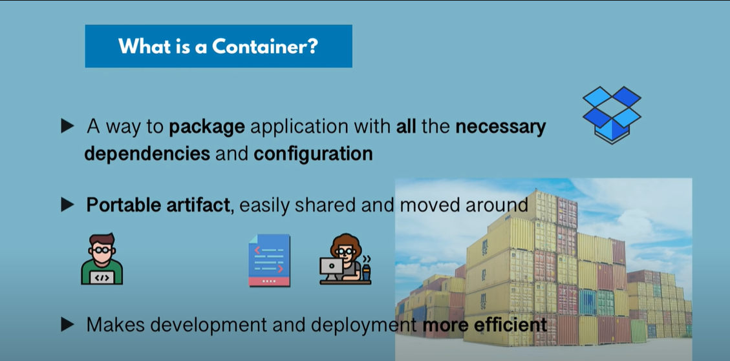

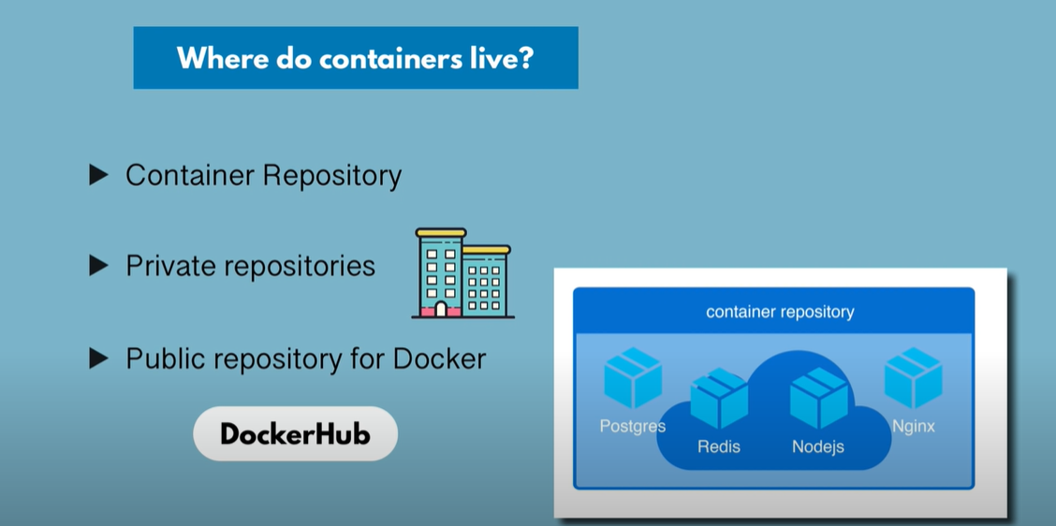

Docker images available in docker hub repository which is public repository

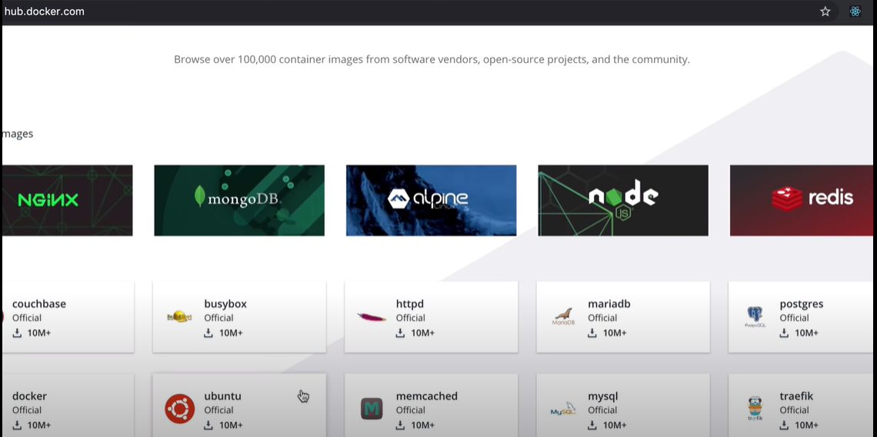

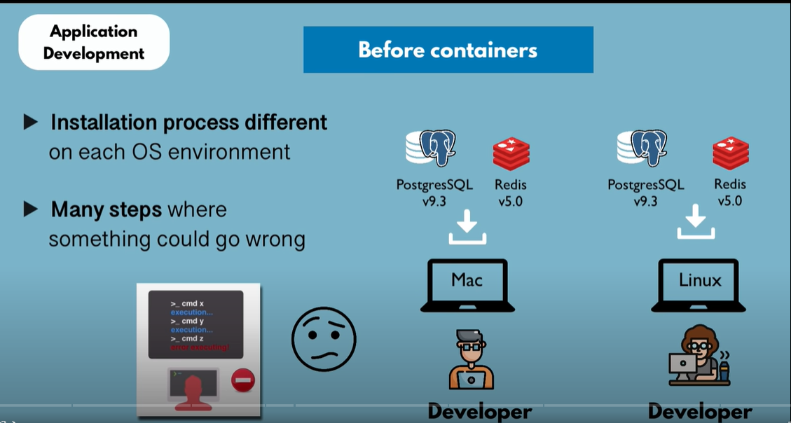

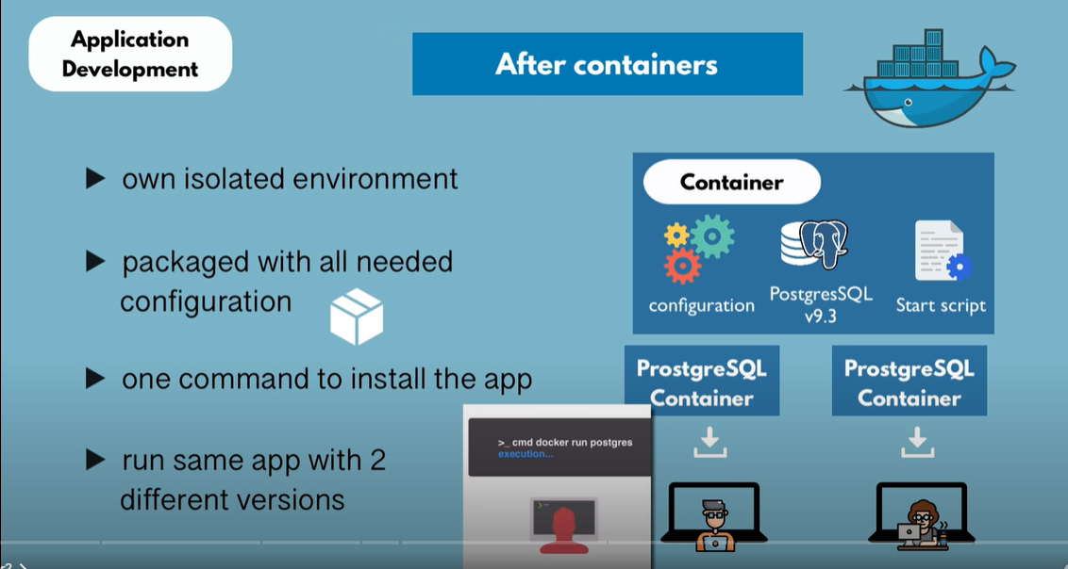

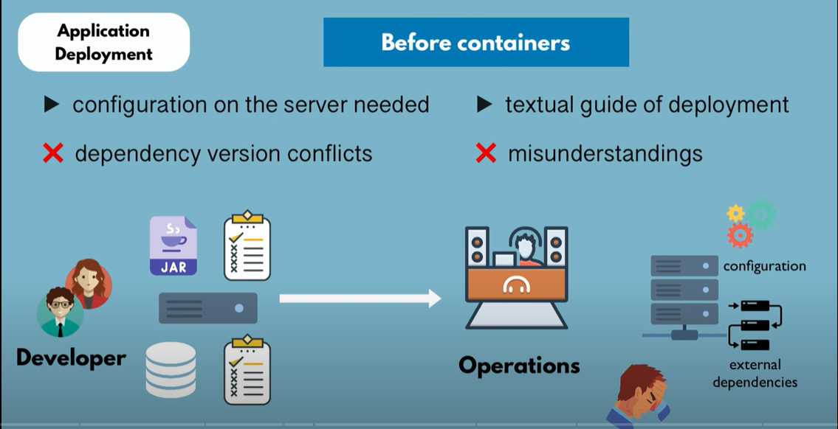

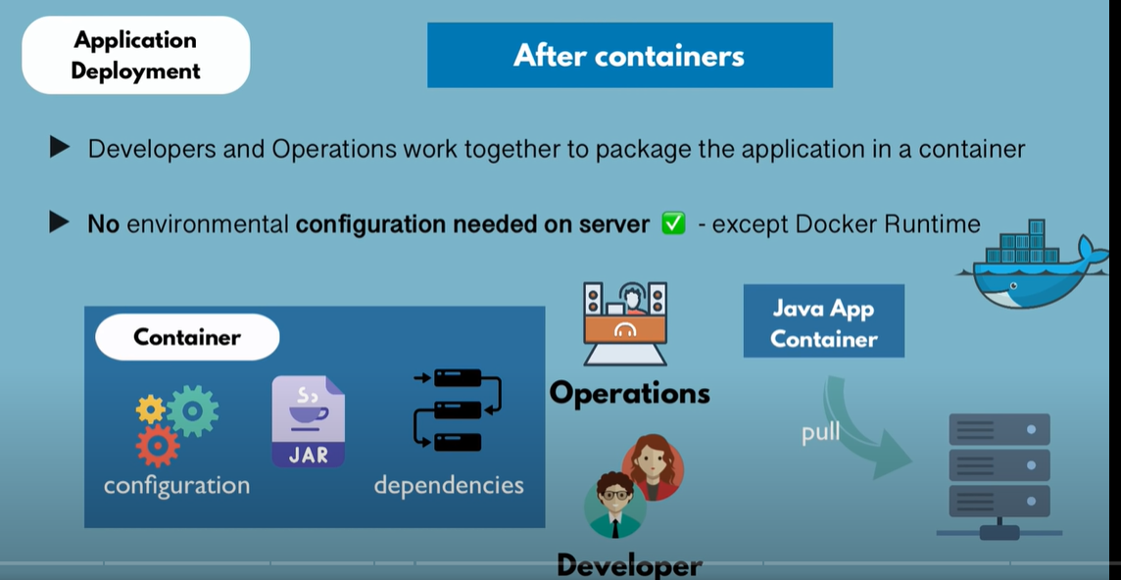

A container consists of Layers of Images.

First is the **Base Image** and then **Application images on top of it**

Once we run any image for first time…multiple layers (Linux base image layer, application layer etc) are downloaded as shown below. And as part of first time run, the download will take more time as it downloads all layers.

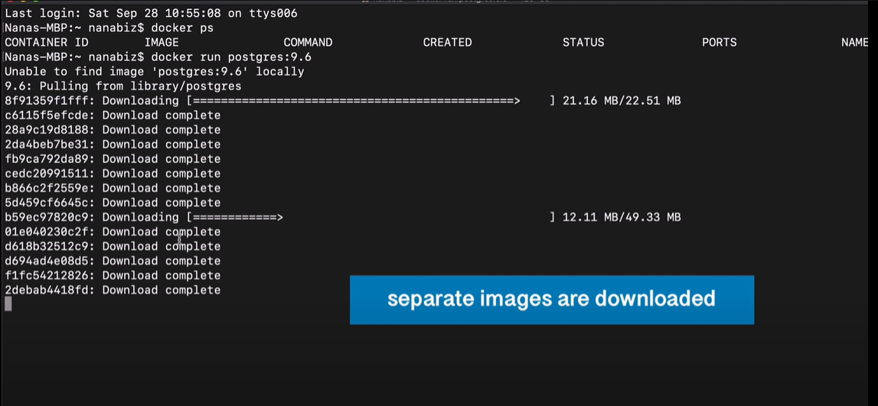

Advantage of having layers: if newer version of Postgres is required. Then only the app image with newer version is downloaded. Other layers need not be downloaded again. And this time download time will be less as only app image id downloaded.

In below screenshot, **Already exists** means those images are already present and only newer version of app is downloaded

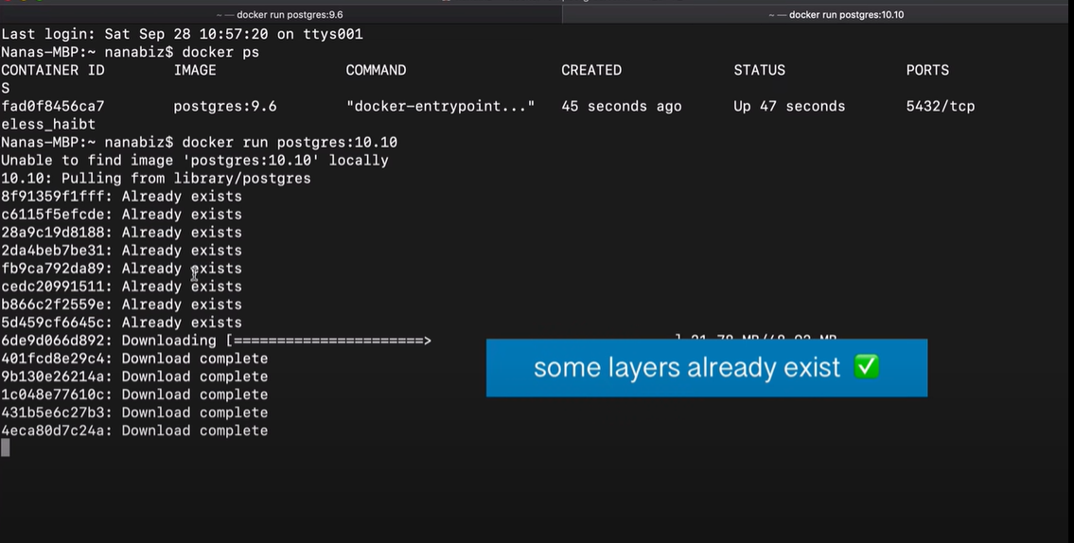

Running version of an image is called a container

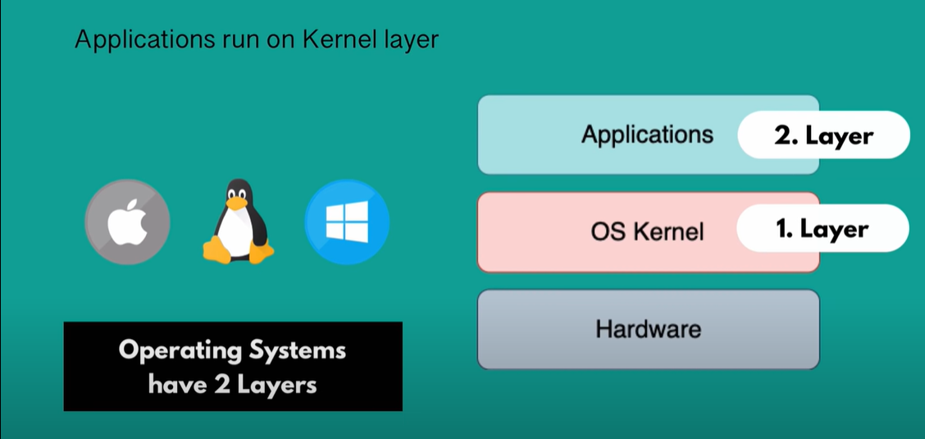

Docker virtualizes only the Application layer, while VM virtualizes the application and Kernel

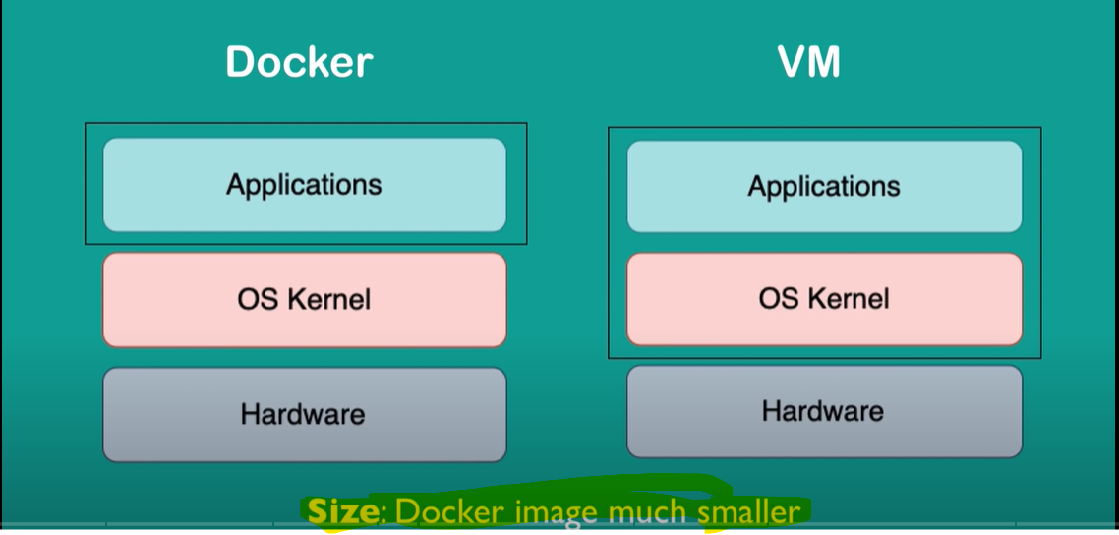

Dockers are Speed in terms of start and run

VM of any OS can run on any OS host, but the same is not true for Docker.

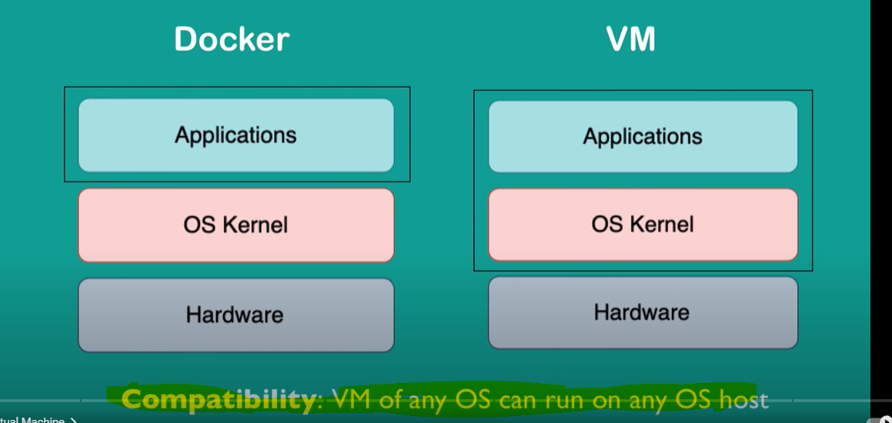

Below image shows a Linux based docker image is not compatible with windows kernel. This is applicable till Windows 10.

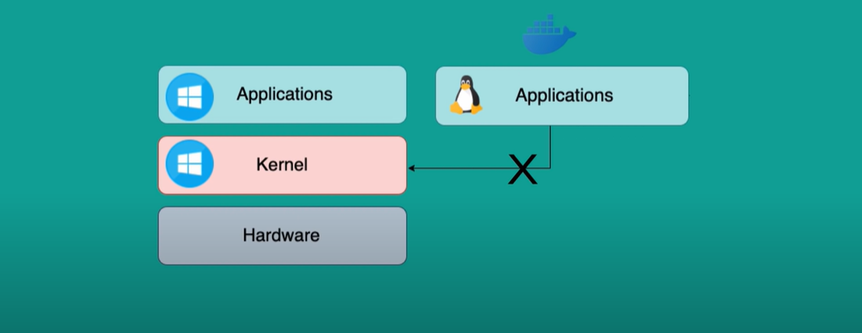

Workaround: Docker toolbox will help to run any images on any kernels.



